

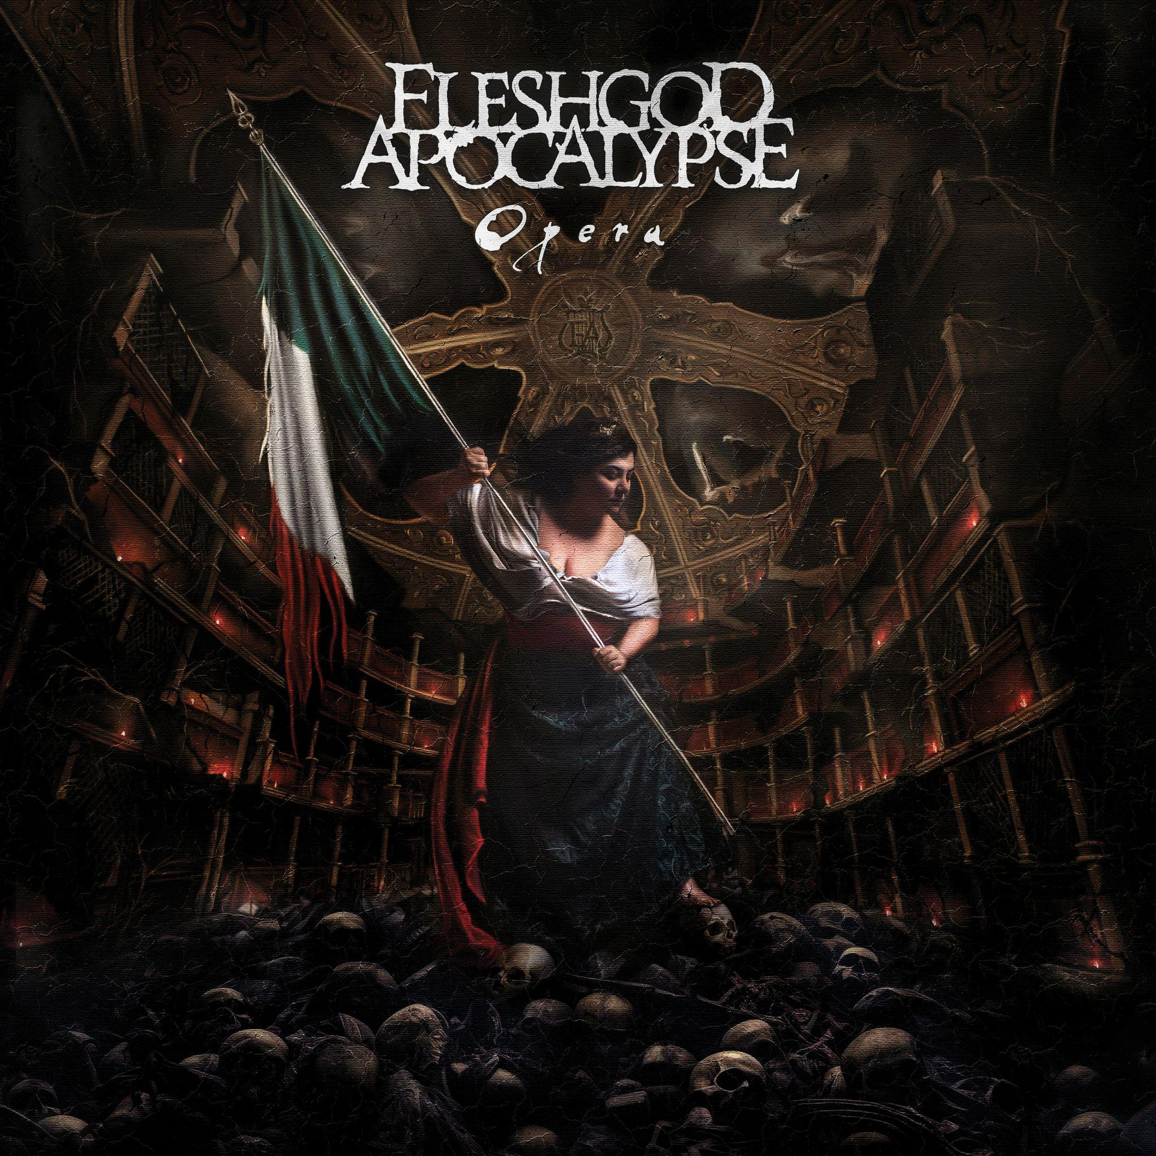

***FLESHGOD APOCALYPSE***

***Opera***

*Release Date: August 23rd, 2024*

| **Line up:**  **Francesco Paoli | Vocals, Bass**  **Veronica Bordacchini | Vocals**  **Francesco Ferrini | Piano**  **Fabio Bartoletti | Guitar**  **Eugene Ryabchenko | Drums** | ***FLESHGOD APOCALYPSE*** online:  [www.facebook.com/fleshgodapocalypse](https://www.facebook.com/fleshgodapocalypse)  [www.instagram.com/fleshgodofficial](https://www.instagram.com/fleshgodofficial/?hl=en)  [www.tiktok.com/@fleshgodofficial](https://www.tiktok.com/@fleshgodofficial)  [www.youtube.com/user/fleshgodapocalypse](https://www.youtube.com/user/fleshgodapocalypse)  [www.twitter.com/FApocalypse](https://twitter.com/FApocalypse) |
| --- | --- |
|  |  |
|  |  |

Formed in 2007, Italian Symphonic Death Metal maestros **FLESHGOD APOCALYPSE** are finally back with their fifth and brand new album titled ***Opera***, a gut-wrenching musical journey inspired by the tragic mountain climbing accident that occurred to their frontman and mastermind **Francesco Paoli**, in 2021.

*“The best stories always come from pain, it's a bitter truth yet undeniable,”* says **Francesco**. *“That's why human struggles have always been an unending source of inspiration for artists throughout history. But one thing is creating art that gives voice to someone else’s tribulations, another is accepting to bare your soul to the world and reveal your weaknesses and frailties, while attempting to turn them into new resources for your own creativity. It's a dangerous game, since we never know what our twisted mind has in store for us, but it's a game you must play if you really want to bring your art to the highest level and leave a trace that has a deeper meaning, not just mere entertainment for distracted people.”*

*“After my fall, I woke up in a hospital, underwent several surgeries, constantly getting terrible news and spending many months not knowing if I would ever be able to play an instrument again. I felt condemned. Fear, painkillers, wheelchairs have been daily food for my frustration. Retracing what happened that day, as well as the days, months, years after, has been such an exhausting and frightening journey, in which I had to face my demons once again and deal with memories I hoped I had left behind.”*

*“Was all this worth it? Let the others tell. All I can say is that, although it was clear that this was the right thing to do, we could not even remotely imagine how strongly this process would have affected our songwriting, igniting our creativity and reinvigorating our attitude after years of deep coma due to the pandemic. We managed to turn one of the worst things in life into a work of art, that embodies our personal and artistic growth and takes the listeners on a rollercoaster of emotions, where they can experience what I've been through hand in hand with me. It's a waking nightmare but that's how life is sometimes, just scary.”*

The whole album is structured like a 10-act theatrical piece, as the title itself, ***Opera***, draws a clear thread with the everlasting tradition of Italian classical music theater and its icons, from **Giuseppe Verdi** to **Giacomo Puccini**, combining it with the epic brutality of death and symphonic metal, which has become their trademark sound.

On the trail of such powerful heritage, embodied by **Veronica Bordacchini**’s outstanding vocal performance, each chapter enlightens a different angle of Francesco’s story, both musically and lyrically.

**Francesco** adds: *“In my visionary representation of this journey, that begins with my near death experience and culminates in a much desired physical and psychological rebirth, I wanted to frame every single step of my calvary, as if they were acts of an "Opera Lirica", with dialogues or even confessions to imaginary characters, who have been constant presences throughout my whole (mis)adventure. Death, Life, Hope are among these entities, masterfully interpreted by Veronica, that from time to time assist or prevent me from digging deeper in my memory and personality, examining objectively my emotional states and behaviors and finding a sense to all this. This album tosses you in a vortex of discomfort and uncontrollable feelings, where you can experience pain, fear, desperation, anger, frustration, but also resolve, courage, hope and a profound desire for redemption.”*

*“In fact, besides being grateful for the privilege of sharing my personal experience through* ***FLESHGOD APOCALYPSE***  *art, I strongly believe that this album is a solid manifest of resilience, and I hope that my story will inspire people who got “lost” for whatever reason. Since the accident I’ve been posting on socials about my rehab and received hundreds of messages of appreciation for that. People need motivation, need examples that can make them restart believing in themselves. And for me, this is part of the game, this is the best way I can give them something back after all these years of loving support. Life is a wonderful thing, even when everything around us seems to be falling apart we must find a meaning for existing and, unexpectedly, sometimes second chances can be way more exciting than the first ones.”*

Mixed and mastered by Grammy-nominated producer **Jacob Hansen** (Volbeat, Epica, Arch Enemy), ***Opera*** definitely marks another step forward for the band, incorporating new suggestions into that unique blend that **FLESHGOD APOCALYPSE** are renowned for: sheer violence, majestic orchestrations and soaring melodies.

While showcasing new maturity in songwriting, the album retains a strong stylistic bond with the band’s previous efforts, from the furious blast beats of ‘**Mafia**’ and ‘**Agony**’ to the epic, grandiose atmospheres of ***Labyrinth*** or ***King***, along with the unquestionable technical prowess that made ‘**Oracles**’ and ‘**Veleno**’ instant classics among fans of the genre.

Such an ambitious musical endeavor called for an equally impressive artwork, a team effort between two arising Italian talents (artist extraordinaire **Felicita Fiorini** and visionary photographer **Francesco Esposito**), following the path traced by baroque painters like **Caravaggio** and **Artemisia Gentileschi**.

Born in 2007, **FLESHGOD APOCALYPSE** quickly established themselves among the leaders of symphonic death metal. As of today, some of their most acclaimed releases such as ***Agony*** (2011) or ***King*** (2016) are still considered milestones by fans and critics alike. With this new record, they're setting the bar even higher, pioneering what looks like a completely new sub-genre that might be called “*Opera Metal*”: an unprecedented mix of extreme music and theatrical elements.

For sure, this won't sound surprising for anyone who has witnessed one of their intense live performances.

The band is now preparing a huge worldwide touring campaign in support of this new masterpiece.

**FLESHGOD APOCALYPSE** are now ready to take everyone to the ***Opera***.